CURATION DATA DOWNLOAD

Type
Curation Data Download is a functional module of the NCIA application.

Purpose
NCIA users have requested that they have relevant curation data included in any selected image downloads. By relevant, that is to say that any curation data that any associated or related curation data for any image, series, study, or patient referred to in the download should be included. The module allows a user with sufficient privileges to include a download of submitted Curation Data for the set of images that they have selected to download.
An XML file whose backing schema is shown in <WHERE>, and added to source control, will be used as the container of this information.
This module implements the requirements described in the “Download Curation Data” section of the use cases document.

Dependencies
The user must select images from an image search and then select to download those images. It is implied that if the user is allowed to view the images that they are also allowed to see the curation data that is related to those images, series, studies or patients.

Preconditions
User must have the security rights to access this module (see section 1.1.12) and curation data must be available that is relevant to the users currently selected download.

Interfaces
N/A

APIs

dom4j-1.6
The dom4j API is a basic XML handling API for Java, and is already a functional dependency of the NCIA application. The version utilized is version 1.6, and what is currently in the existing application.

Processing
The sequence diagram Figure 1- Download Curation Data Sequence Diagram demonstrates the processing flow that occurs in the Curation Data Download module. The ZipManager is called when a download is selected by the user, from the user interface.
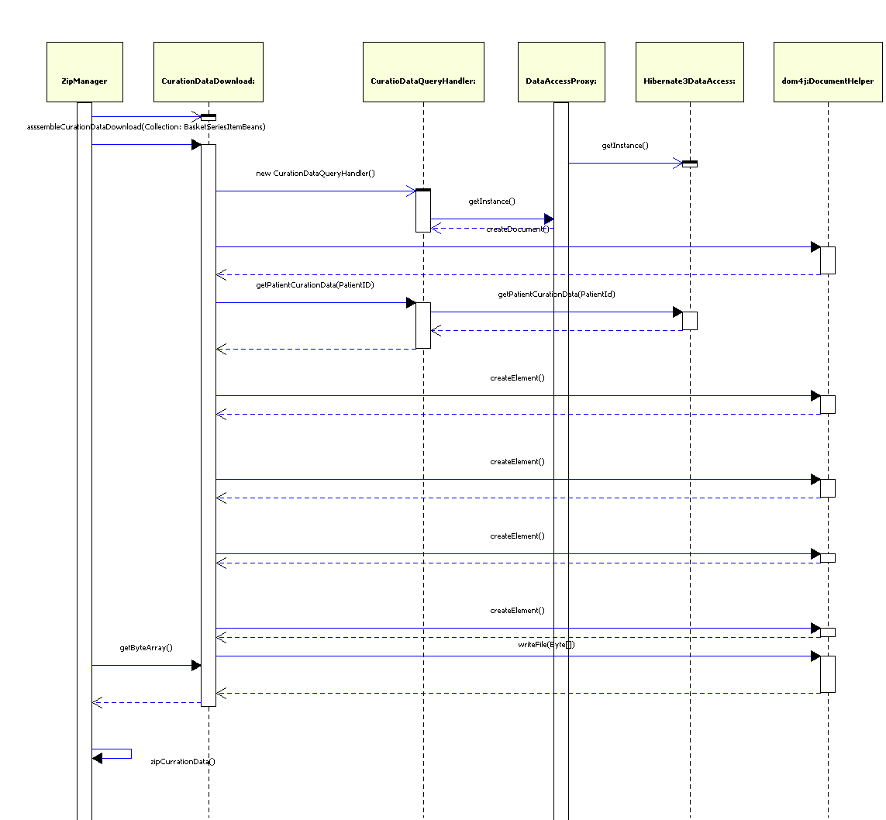
Figure 1- Download Curation Data Sequence Diagram

Backing Beans
N/A

Data Transfer Objects
The BasketSeriesItemBean is the only DTO of concern and requires no special changes to accommodate this functionality.

Other Classes

CurationDataDownload
This class is responsible for making the necessary calls to: process the incoming BasketSeriesItemBeans, gather the curation data from the persistence tier, and construct the XML document into a byte array for storing in the Zip file.

CurationDataQueryHandler
This is responsible for constructing the relevant query to retrieve the curation data for the patients specified.

DataAccessProxy
The DataAccessProxy acts as the factory for access to the updateable domain objects that access the database through Hibernate, and not through the toolkit.

Data
There are no special data objects created for this functionality. However the XML file that will contain encapsulate the data adheres to the following schema shown here:
<xsd:schema xmlns:xsd="http://www.w3.org/2001/XMLSchema" xmlns:curation="http://imaging.nci.nih.gov/curation_data_xml" targetNamespace="http://imaging.nci.nih.gov/curation_data_xml" elementFormDefault="qualified">
<!-- Common Data Element Type -->
<xsd:complexType name="cde_type">
<xsd:attribute name="name" type="xsd:string"/>
<xsd:attribute name="public_id" type="xsd:string"/>
<xsd:attribute name="public_id_version" type="xsd:string"/>
</xsd:complexType>
<!-- Annotation File Name : This can be fleshed out later if the Requirements Change -->
<xsd:complexType name="cde_value_type">
<xsd:attribute name="value" type="xsd:string"/>
</xsd:complexType>
<xsd:complexType name="annotation_file">
<xsd:attribute name="name" type="xsd:string"/>
</xsd:complexType>
<!-- Curation Data Type-->
<xsd:complexType name="curation_data_type">
<xsd:sequence>
<xsd:element name="cde" type="curation:cde_type"/>
<xsd:element name="cde_value" type="curation:cde_value_type"/>
<xsd:element name="annotationFile" type="curation:annotation_file" minOccurs="0"/>
</xsd:sequence>
<xsd:attribute name="timestamp" type="xsd:string"/>
<xsd:attribute name="curator_id" type="xsd:int"/>
<xsd:attribute name="annotation_file_present" type="xsd:boolean"/>
</xsd:complexType>
<!-- Image Data Type-->
<xsd:complexType name="image_type">
<xsd:sequence>
<xsd:element name="curationData" type="curation:curation_data_type" minOccurs="0"/>
</xsd:sequence>
<xsd:attribute name="id" type="xsd:string"/>
<xsd:attribute name="series_id" type="xsd:string"/>
</xsd:complexType>
<!-- Series Data Type-->
<xsd:complexType name="series_type">
<xsd:sequence>
<xsd:element name="curationData" type="curation:curation_data_type" minOccurs="0"/>
<xsd:element name="image" type="curation:image_type" minOccurs="0"/>
</xsd:sequence>
<xsd:attribute name="id" type="xsd:string"/>
<xsd:attribute name="study_id" type="xsd:string"/>
</xsd:complexType>
<!-- Study Data Type -->
<xsd:complexType name="study_type">
<xsd:sequence>
<xsd:element name="curationData" type="curation:curation_data_type" minOccurs="0"/>
<xsd:element name="series" type="curation:series_type" minOccurs="0"/>
</xsd:sequence>
<xsd:attribute name="id" type="xsd:string"/>
<xsd:attribute name="patient_id" type="xsd:string"/>
</xsd:complexType>
<!-- Patient Data Type-->
<xsd:complexType name="patient_type">
<xsd:sequence>
<xsd:element name="curationData" type="curation:curation_data_type" minOccurs="0"/>
<xsd:element name="study" type="curation:study_type" minOccurs="0"/>
</xsd:sequence>
<xsd:attribute name="id" type="xsd:string"/>
<xsd:attribute name="project_name" type="xsd:string"/>
</xsd:complexType>
<!-- curation_download_type is the Root Type -->
<xsd:complexType name="curation_download_type">
<xsd:sequence>
<xsd:element name="patient" type="curation:patient_type" minOccurs="0"/>
</xsd:sequence>
<xsd:attribute name="id" type="xsd:string"/>
<xsd:attribute name="date" type="xsd:date"/>
</xsd:complexType>
<!-- The Root element of the Schema -->
<xsd:element name="curationDownload" type="curation:curation_download_type"/>
</xsd:schema>

Presentation
There is no modification to the presentation for this functionality.

References to Other Documents
Refer to the NCIA use cases document for more details of the functionality.

Impact to Other Components
There is no impact to other components.

System Security
Users are only allowed to view image data will be able to see curation data for those images.

Error Handling
Error conditions that will be generated either from parsing BasketSeriesItemBeans or from accessing the database will be handled and logged within the CurationDataDownload class. If the curation download fails for any reason, the XML file will contain a single message stating that there was an error creating the curation data with a time stamp for later debugging.

Performance
Performance requirements were not specified for this functionality so the following assumptions have been made:
Concern | Assumption
Max Concurrent Users | 35
Max Concurrent Downloads | 6
Max curation rows per patient (as per ACRIN data set) | 500
Figure 2- Performance Assumptions

Perhaps the biggest concern for the curation data download was performance and memory management. Because the download activity is performed asynchronously, the length of time or number of cycles to create the actual XML is of little concern except as it relates to CPU cycle sharing with other threads in the JVM and on the processor. The standard Sun’s Hotspot JVM and its ability to handle threads should suffice.
However, the amount of JVM memory that may be required to construct a complete set of curation data, for a rather large download was an immediate concern. We were also concerned with unnecessarily or excessively tying up the data base connection pool given the current database resource usage by the NCIA application.
Based on our current heaviest user, we can expect about 500 rows in a single result set. Since each row means a single CurationData hibernate object, a calculation was performed on the max memory footprint of a single object on the JVM. By our estimate we anticipate a memory footprint during processing of no more than 1kB per fully populated object and 500kB per curation data result set.
With an estimated concurrent user base of 35 expecting that 6 may be performing a download at any single time, our total memory footprint of the CurationData objects should not exceed 3MB at any one time.
Additionally, during the creation of the dom4j XML document elements will be created and retained. The foot print of each of these din4j elements should not exceed 300 bytes, meaning that we can expect with 6 concurrent downloads 5000 rows (where 1 row maps to 1 element as it is in the current schema), we can expect in the worst imagined case about another 9 MB footprint, when the document is completed. When all reasonable memory allocations converge we expect no more than 12-15 MB devoted to the construction of the curation data download file.

Migration
N/A

